# Submitting to the Apple App Store

## Sign-up for the Apple Developer Program

The first step that should be completed when commencing with any app development with the intention of submission to the Apple App Store is to sign-up for the Apple Developer Program. It costs $99 annually and includes the following benefits:

* Access to submit apps to the App Stores on all Apple platforms
* Ability to create Safari extensions and list them in the extension’s gallery
* Access to Beta versions of Apple software
* Testing tools like TestFlight
* App analytics and advanced app capabilities

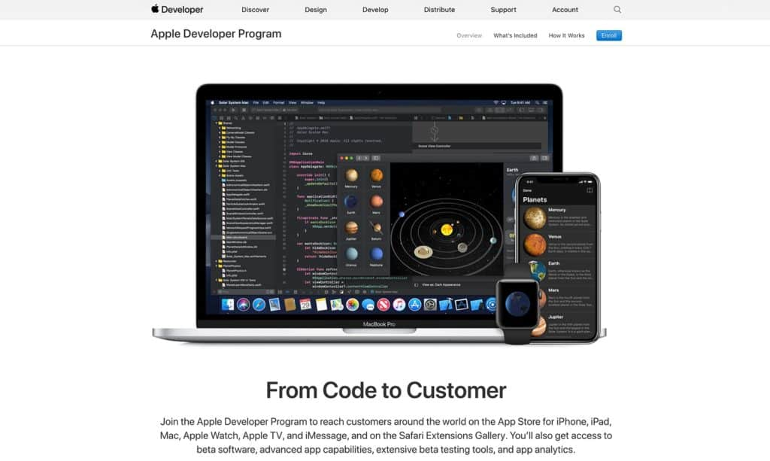

Apple Developer Program

An important point to consider is that annual membership is essential for your app to remain on the app store, once annual membership expires, Apple will remove all app submissions related to that account.

Once the signed-up, access to **App Store Connect** is granted by Apple. This is the portal used to manage all things to do with the Apple store, the dashboard looks like this:

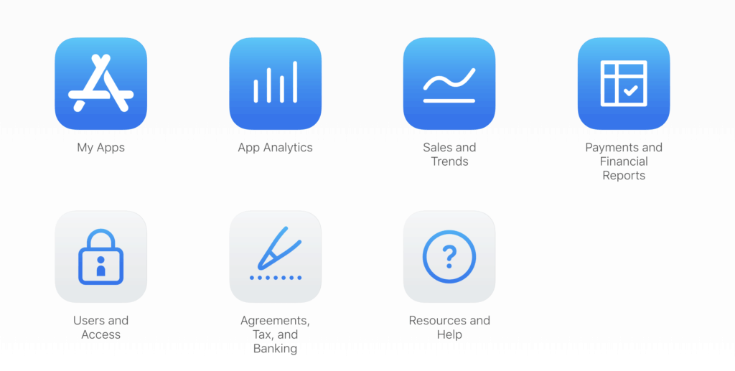

App Store Connect Dashboard

## Prepare your app for submission

Before your app is live in the Apple App Store, it needs to go through an app certification process, this is where an Apple representative essentially tests the app and makes sure it conforms to the guidelines for the Apple App Store.

Full Apple guidelines can be found here: <https://developer.apple.com/app-store/review/guidelines/>

Before submission:

* Test your app for crashes and bugs
* Ensure that all app information and metadata is complete and accurate
* Update your contact information in case App Review needs to reach you
* Provide an active demo account and login information, plus any other hardware or resources that might be needed to review your app (e.g. login credentials or a sample QR code)
* Enable backend services so that they’re live and accessible during review
* Include detailed explanations of non-obvious features and in-app purchases in the App Review notes, including supporting documentation where appropriate
* Check whether your app follows guidance in other documentation

Test and fix any bugs

If the Apple reviewer can crash your app reliably, then you will be denied a pass. When you’re testing, don’t simply test it under normal conditions. Try low network connectivity conditions, low storage conditions, test it on older devices etc. As a member of Apple Development Program, you are allowed access to TestFlight which should be used to test the app.

## Create Your app Store Listing via App Store Connect

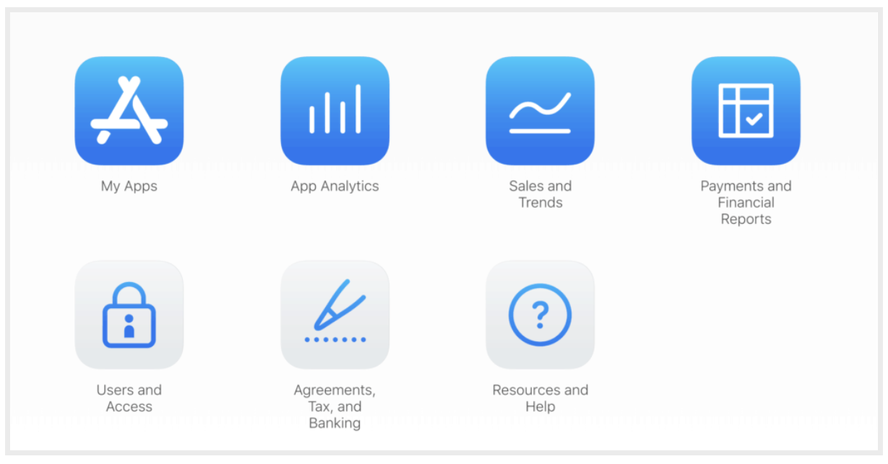

Once the app has been approved, the app can be published to the App Store via App Store Connect, firstly log in. To publish an app, go to the My Apps menu and select the “+” option to create a new app. If you are looking to submit an update to an existing app, the steps are similar but instead of adding a new app, you’ll be selecting an existing app instead.

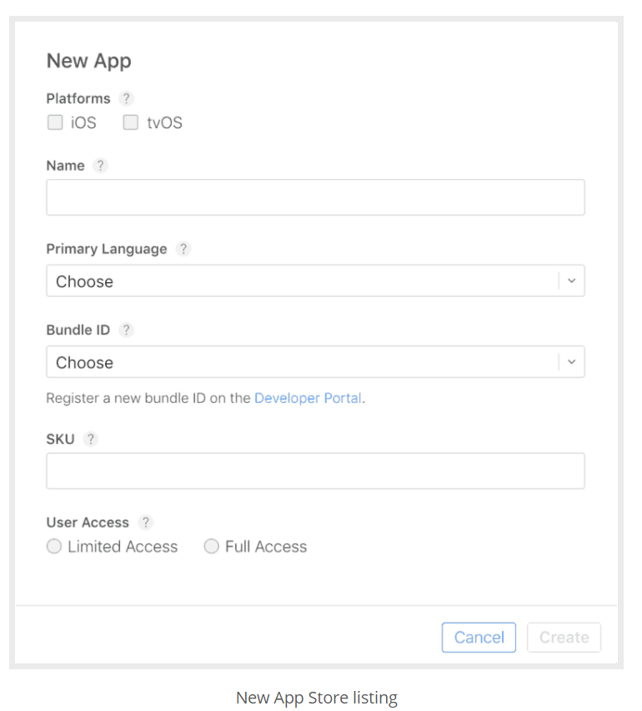

## Make your App Store screenshots

As previously mentioned, screenshots must be provided to the App Store, as the App Store provides apps for devices such as phone, tablet and watch devices, screenshots must be submitted in several dimensions, see specifications below:

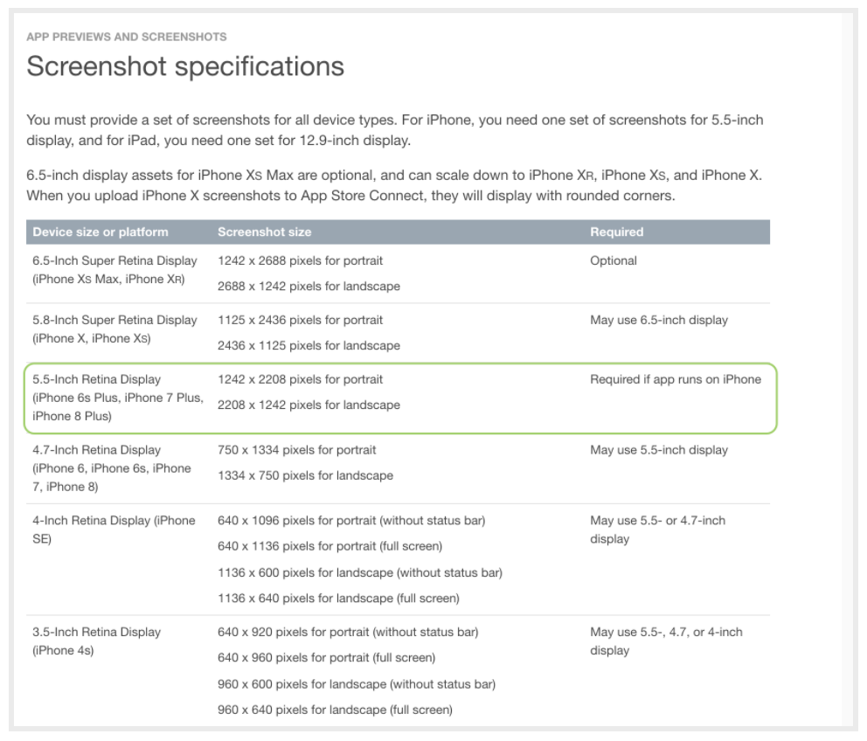

App Store Screenshot Dimensions

Once all screenshots have been completed using Figma etc, these can be simply uploaded to the app store by going to the listing

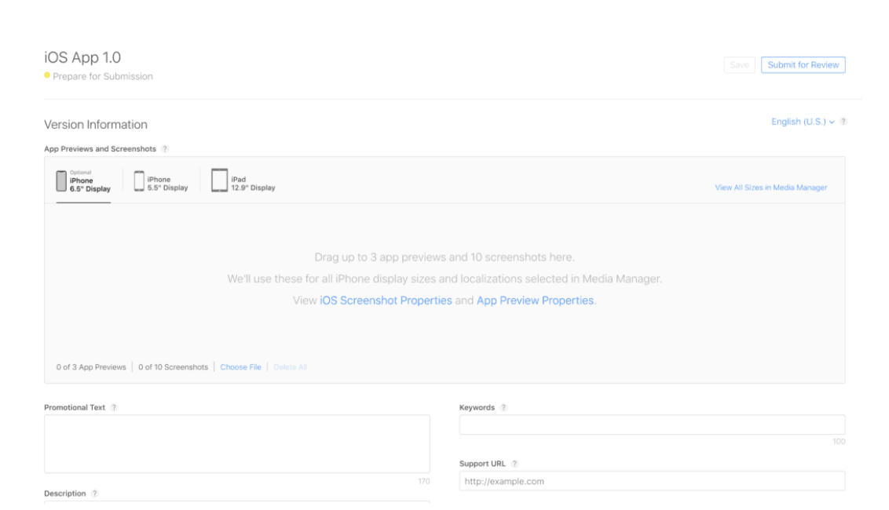

Upload your app store screenshots

## Upload your app to App Store connect using Xcode

Once the app runs properly and is free from errors, the app can be submitted using Xcode. For this, you need to have your signing and team information set up in Xcode. Also, the version number of app submission should be set to v.1.0.0 as it is a new app.

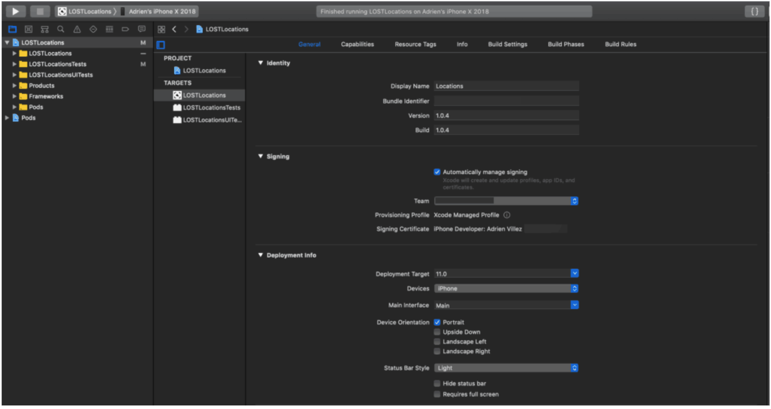

Publishing an app with Xcode 11 is simple. Where it used to take multiple steps, certificates, profiles, etc. now Xcode is smart enough to enable or create all of those by itself.

To create the full app archive, you first need to select the Generic iOS Device from the list of simulators.

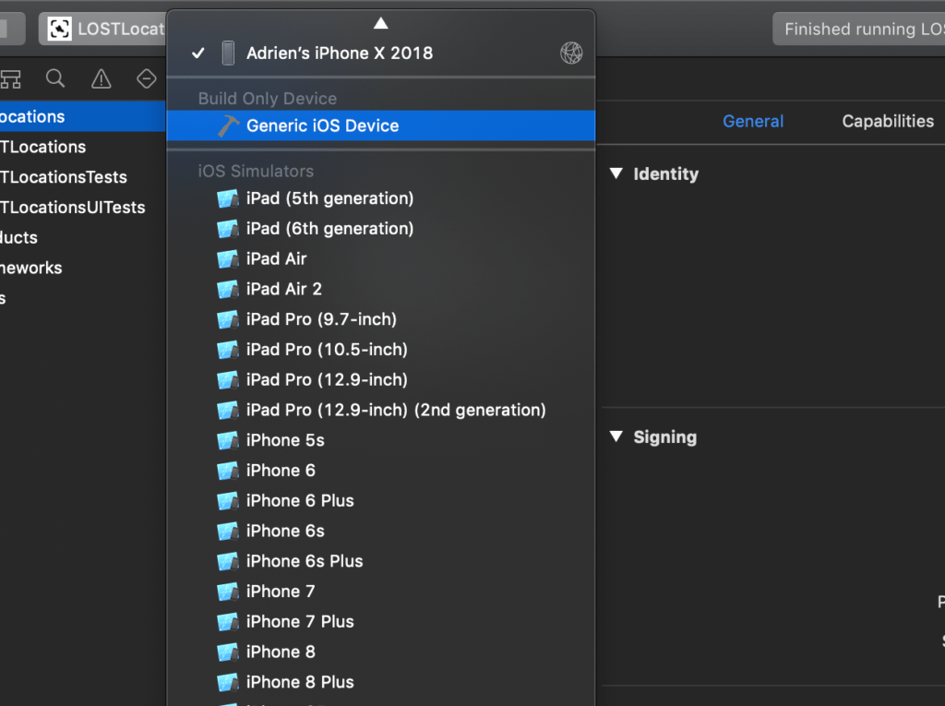

Now go to **Product** >> **Archive** and let it bundle your app. This can be a lengthy process depending on the size of the app.

[](https://codewithchris-wpengine.netdna-ssl.com/wp-content/uploads/2018/10/04-Archiving.png)

Once this is done, the Archive window will open and this is where you can manage all the archives generated by Xcode. Every time you select Archive in the menu, Xcode will bundle a new archive for App Store Connect. If there any duplicates or older ones, just delete them from this list.

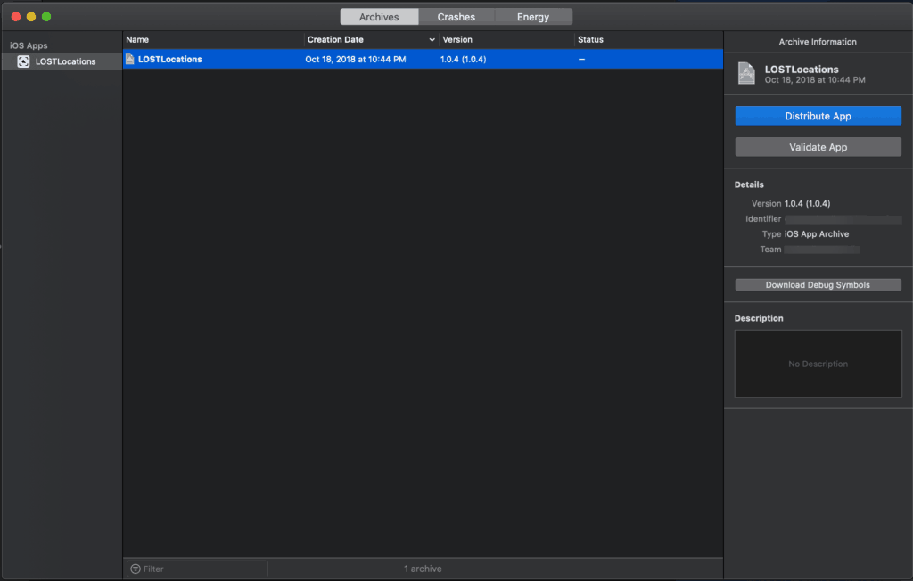

Now select the archive and choose **Distribute App**. You’ll be prompted to select the method of distribution:

[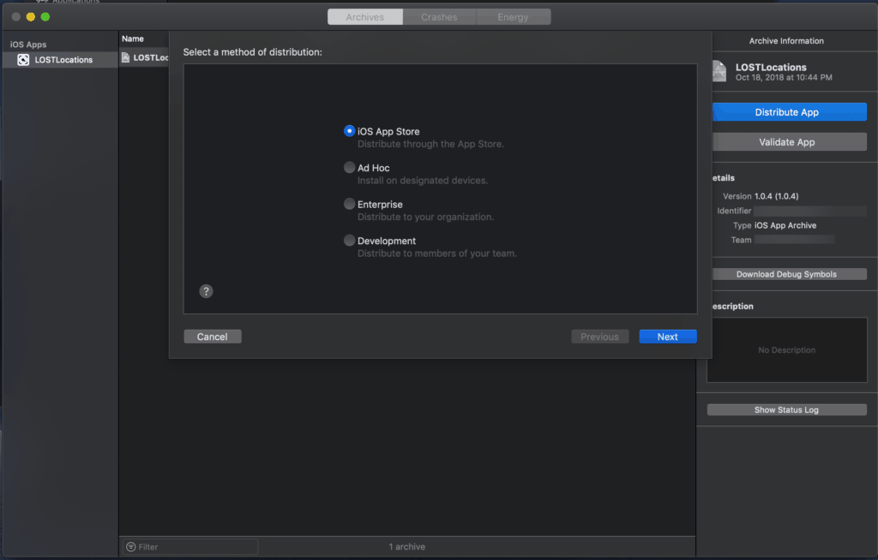](https://codewithchris-wpengine.netdna-ssl.com/wp-content/uploads/2018/10/06-Distribution-List.png)

Once you have selected **iOS App Store**, it will go over a couple of checks and validations to make sure you are not uploading a broken app. If something happens, there is a great chance Xcode will stop you here and you’ll have to go back to coding or adding missing assets like icons.

[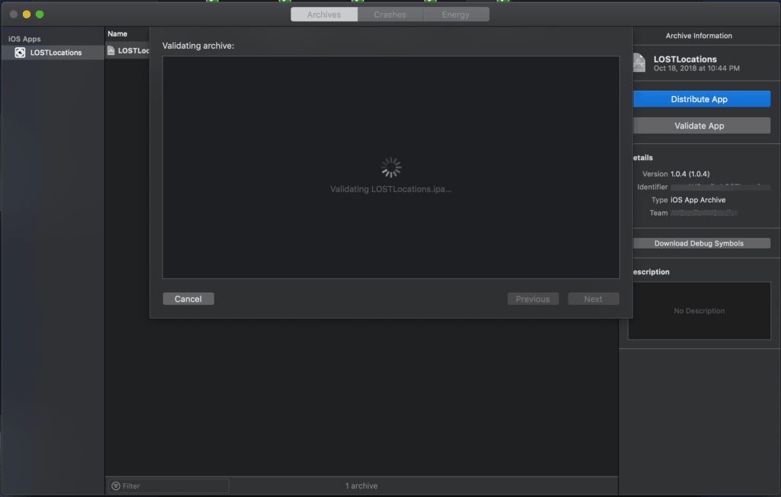](https://codewithchris-wpengine.netdna-ssl.com/wp-content/uploads/2018/10/07-Validation.png)

If Xcode doesn’t find anything wrong with the archive, the upload process will follow. Once again, the upload time will vary depending on the archive size and your internet connection.

[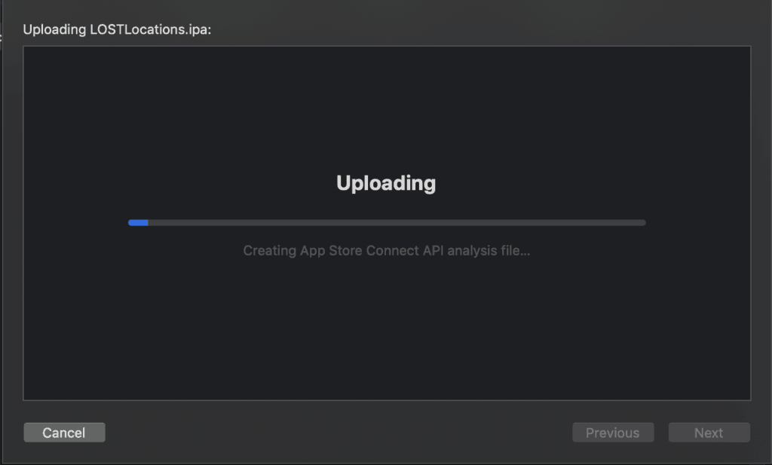](https://codewithchris-wpengine.netdna-ssl.com/wp-content/uploads/2018/10/08-Uploading-to-iTunes-Connect.png)

Once completed, you will see a final window like this. Your app is halfway there to the iOS App Store.

[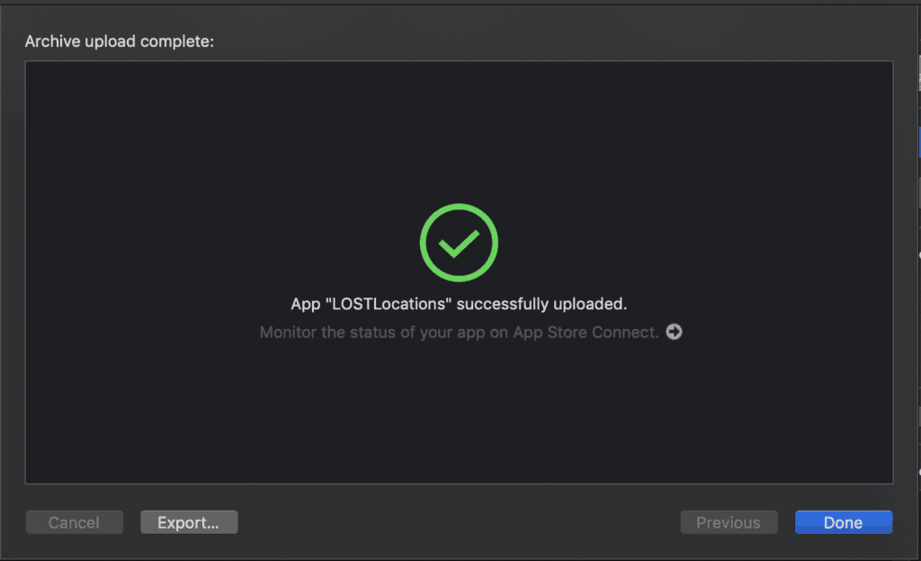](https://codewithchris-wpengine.netdna-ssl.com/wp-content/uploads/2018/10/09-Success.png)

## Submit your app for review

Now it is time to add the build you exported from Xcode. The archive was sent via Xcode but App Store Connect needs some time to process it.

Once the app has been titled, described, and priced with screenshots, then the build is ready to be selected.

[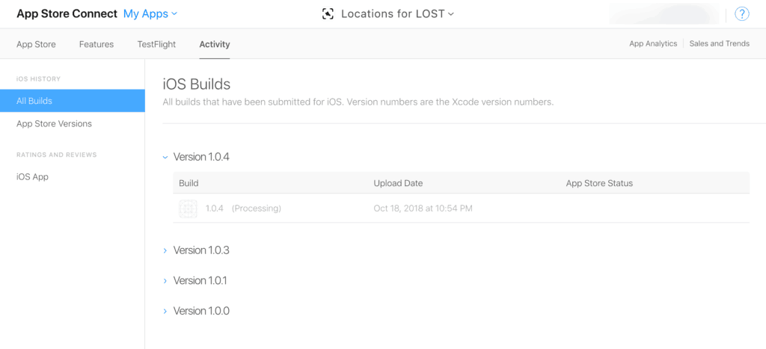](https://codewithchris-wpengine.netdna-ssl.com/wp-content/uploads/2018/10/Update-Processing.png)

Select the save button on the top right of your screen and the “**Submit for Review**” button should turn blue.

There will then be a couple of questions to answer about the app:

[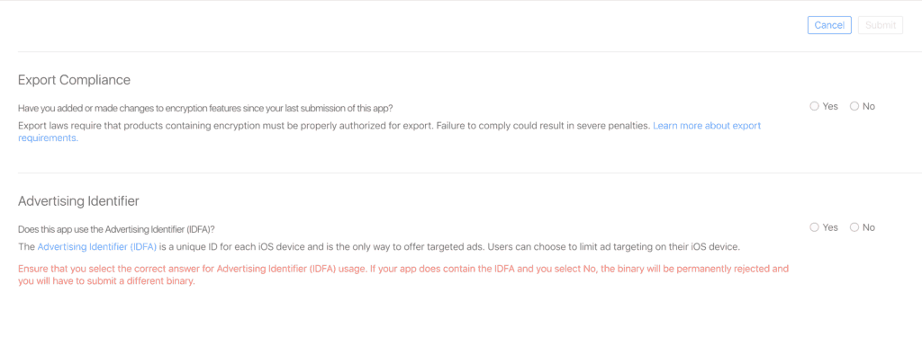](https://codewithchris-wpengine.netdna-ssl.com/wp-content/uploads/2018/10/Question-1.png)

After that, the app will be on the waiting list for the Apple’s certification and review team. The app should now have a yellow tag:

[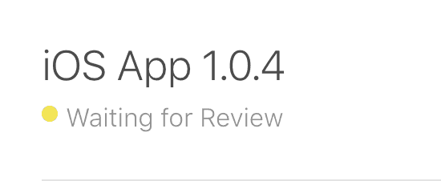](https://codewithchris-wpengine.netdna-ssl.com/wp-content/uploads/2018/10/Waiting-for-Review.png)

The app review process can take around 2-4 days and once completed, the app is now on the App Store! Hello World!

# Submitting to the Play Store

## 1. Get your app information ready

Log into the [Google Play Console](https://play.google.com/apps/publish/) using a Play publisher account. To create an application, select All applications in the left-hand menu. Click on Create Application in order to begin creating the app. Choose a language and enter a title for the app (limit of 50 characters). And continue by clicking Create. On the following page shown below, you’ll add all the relevant information about the app.

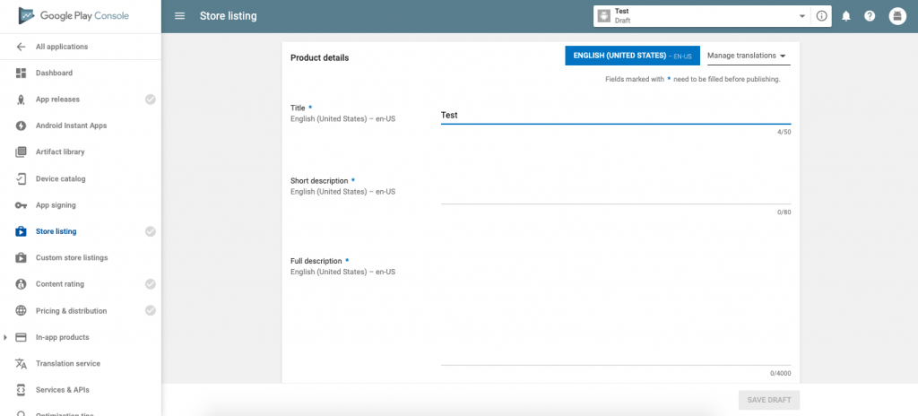

**Short description:** A brief summary of the app. This will be shown on the app’s Google Play Store listing and is critical for convincing people to download the app. Pack the most important and exciting information in the first three lines.

**Full description:** Go into more details about the app. Highlight benefits and key features. This is shown when a user opens the app’s store listing.

**Screenshots:** Essential to show the app in action. Click Add screenshot and upload screenshots of the app. It is required to upload at least two screenshots, but aim for seven or the maximum of eight for the best results and put the best ones at the beginning. To be featured in the Play Store’s “Designed for tablets” list, upload screenshots of the app running on a 7-inch and 10-inch tablet.

**Hi-res icon:** This is the icon that will be shown in Google Play Store and on the users’ devices when downloaded

**Feature graphic:** This is labelled as optional even though it’s essential as the app cannot be featured anywhere on the Google Play Store without a feature graphic. Aim for a bold, vivid, and simple image that promotes your brand with minimal writing.

**Video link:** You can also add a link to a video of your app. This can be a YouTube link.

**Application type:** Whether it’s an app or a game

**Category:** Business, travel, education, etc.

## 2. Upload the APK or app bundle files for your app

After you’ve made sure of all the prerequisites (unique bundle ID, signed app release, and expansion files in the case of a large app) needed to release the app, it’s time to actually upload the files before release. To do this, go to the App releases section from the left menu.

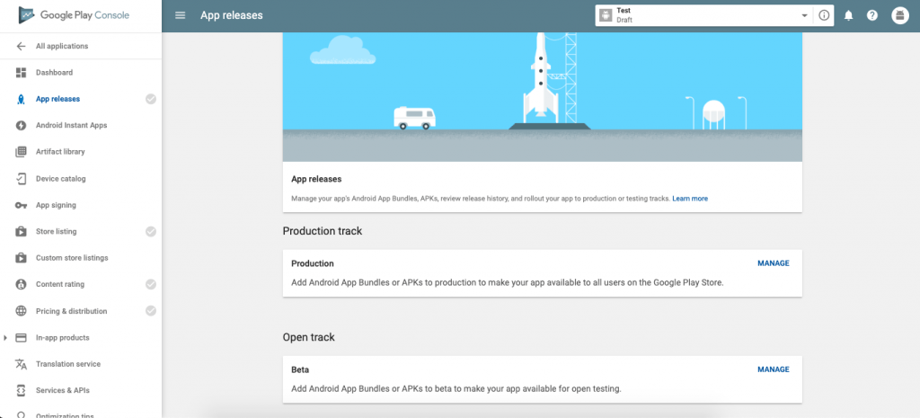

You are given the option of the type of release. Production is the final release to submit a live version of your final app to the Google Play store. [Beta and Alpha releases](https://instabug.com/blog/benefits-of-beta-testing-beyond-bugs-crashes/) give you the opportunity to test the app and receive valuable feedback to make improvements to your app before a final release. [Instabug](https://instabug.com/?src=InstabugBlog&mdm=internal&ref=submit_google_play&term=instabug) gives you the best tools for receiving good feedback from users, all with only one line of code.

After selecting the type of release, you will be redirected to the next page. Click on Create Release to go to the New release to production page.

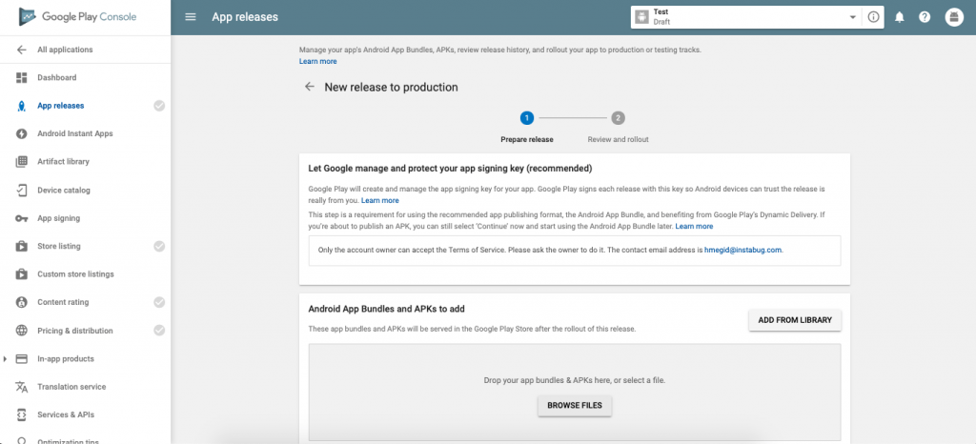

* Choose whether you want to use Google Play app signing on your app or click on OPT-OUT to ignore and sign in locally.
* Click on Browse Files.
* Choose your app’s APK or App Bundle files to upload.
* Click on Review at the bottom right of the page. This confirms and submits your app’s release information.

Before sending the app out into the wild, it needs a content rating and a distribution and pricing plan.

## 3. Set your app’s content rating

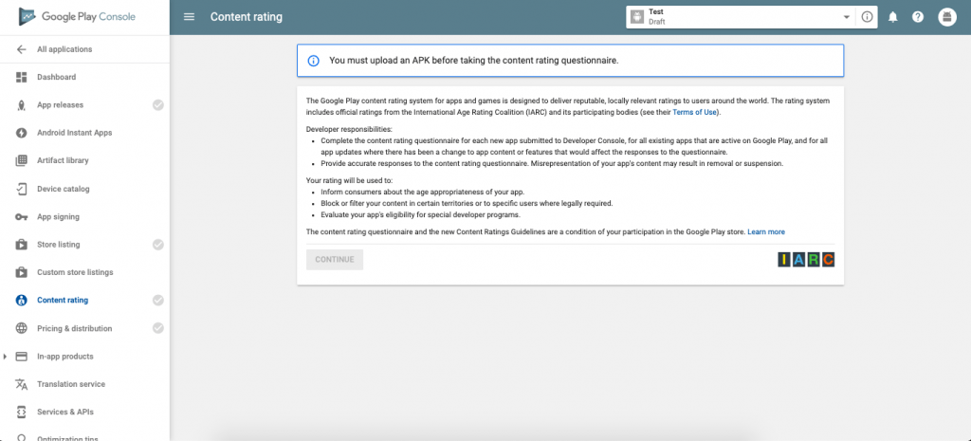

To set the app’s content rating, you will need to go to the **Content rating** page from the left menu.

* Click on Continue.
* Enter your email address and confirm it.>
* From the options, select your app category.
* Go ahead and start filling in the survey for your app rating. This is basically to help Google identify if there is any explicit content in your app.
* Click on **Save Questionnaire**.
* Click on Calculate Rating. This will show you the app rating your app will have on the Play Store.
* Click on Apply Rating to confirm your app’s content rating.

## 4. Set pricing and a distribution plan

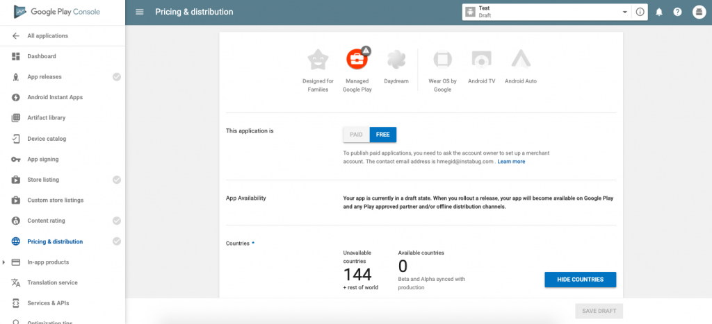

If you plan to have users pay for the app you will need to set the pricing. Also, the app can be distributed to selected countries instead of a worldwide release. Go to the Pricing & distribution page from the left menu.

* Select whether you want your app to be **FREE** or **PAID**. For more details on the paid option check [here](https://support.google.com/googleplay/android-developer/answer/6334373).
* Select **Available** for the countries you want your app released in. Select the Unavailable option otherwise.
* If your app is suitable for children under the age of 13, select Yes for Primary Child-Detected. Otherwise, select No.
* If your app contains ads, check Yes for Contains ads. If not, check No.

## 5. Publish your app

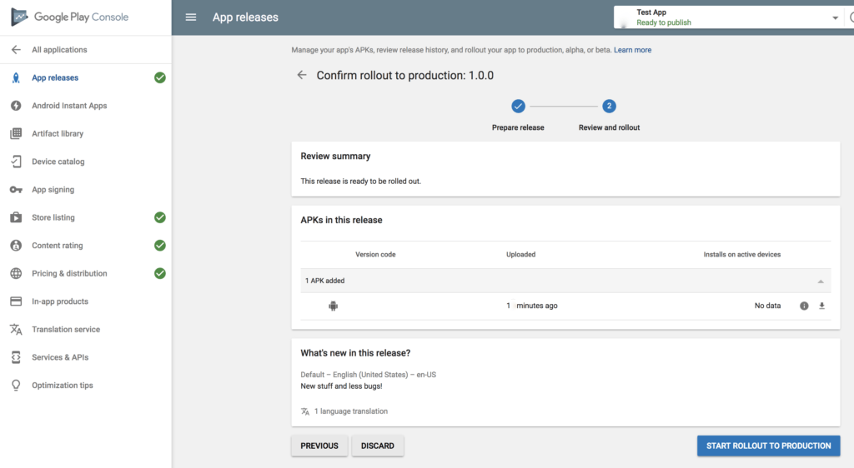

Now that the entire checklist is done and we’re ready to release the app, go back to App releases from the left menu.

* Click on Manage Production (otherwise if you’re releasing a beta or alpha build select that instead).
* Click on Edit Release.
* Then click on Review at the bottom right on the page.
* Click Start rollout to production to finalize.
* Finally, click Confirm when prompted.

Congratulations! You’ve now successfully rolled out the app, and it will send all its information to Google for review. Within two hours your app should be shipped and published on the Google Play store in the countries that you’ve selected.